Statement of Work on Project ‘Integration Factory’

under the METRO Master Agreement for Procurement in the field of IT and the Supplemental Terms – Service
between METRO Digital GmbH and XXX [enter name of SP* entity in the MA] dated xx.xx.xxxx.

Document history
Version history | Author(s) | Change history | Date
1.0 | IF Core Team | Final version | 15.07.2025

Table of Contents
1. Document history 2
2. Definitions 6
3. Background Integration @ METRO 7
1. Historical Background 7
2. Integration Factory and integration pattern definition 7
3. MARS platform 8
4. MFT Platform (METRO File Transfer by JScape) 10
5. MIP (METRO Integration Platform) 12
1. MCC Middleware 15
2. CTA Middleware (Common Template Accounting) 15
3. Architecture 16
4. M.Adapter (METRO Adapter) 17
5. Example screenshots MIP Dashboard 18
6. Developer Portal (M.API) 21
7. Technical solution PoC messaging 21
8. Technical solution PoC API gateway 21
9. Current state and challenges 22
1. General 22
2. CTA specific 23
4. Project description 24
1. Project objective 24
2. Project scope 24
1. Update Developer Portal (M.API) 25
2. Replace MARS (METRO API Repository & Security) with Google Apigee 25
3. Update / integrate MFT (METRO File Transfer by JScape) 25
4. Replace METRO Integration Platform (MIP) 25
3. Project milestones 26
1. Foundation phase 26
2. Roll-out and decommissioning phase 26
4. Project approach 27
5. Project Timeline 29
6. Deliverables 29
7. Roles and Responsibilities 29
1. Project Manager 29
2. Product Manager 30
3. Technical Architect 30
4. Full Stack Engineer (Development) 30
5. Full Stack Engineer (Test) 30
8. Pricing and Payment Terms 32
9. Assumptions 32
10. Glossary 33
11. References 35

Definitions
The following terms used in the SoW in addition to those defined in the master agreement will have the meaning respectively assigned to the below.
Term | Description
LUCA | New instance of SAP
MIP | METRO Integration Platform

Background Integration @ METRO

Historical Background
METRO's current data integration architecture presents a complex and evolving environment, characterized by multiple data sources, a variety of transformation requirements, and a legacy infrastructure that poses challenges for maintenance and scalability. A more detailed description of the current architecture and implementation could be found in the Annex’s of this document and in later chapters.

Integration Factory and integration pattern definition
To transition from the current heterogeneous integration landscape, we introduce the concept of an Integration Platform that acts as an intermediate layer between Provider and Consumer solutions and applications. This Integration Platform is meant to be capable of fulfilling all METRO integration needs by encapsulating all necessary integration patterns with their corresponding technologies.

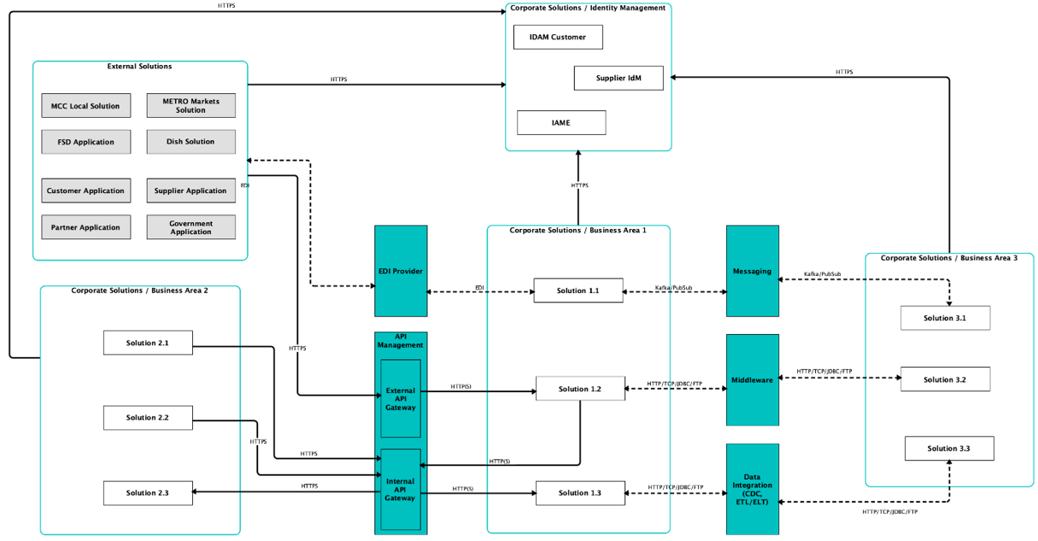
A detailed description of the integration patterns could be found in the Annex 1

MARS platform
The current MARS platform provides
- Dedicated developer portal
- API Gateway & Repository
- Self-service platform
- Central environment for auditing, monitoring, statistics
- Publish, subscribe, secure, maintain and monitor REST or SOAP APIs
- 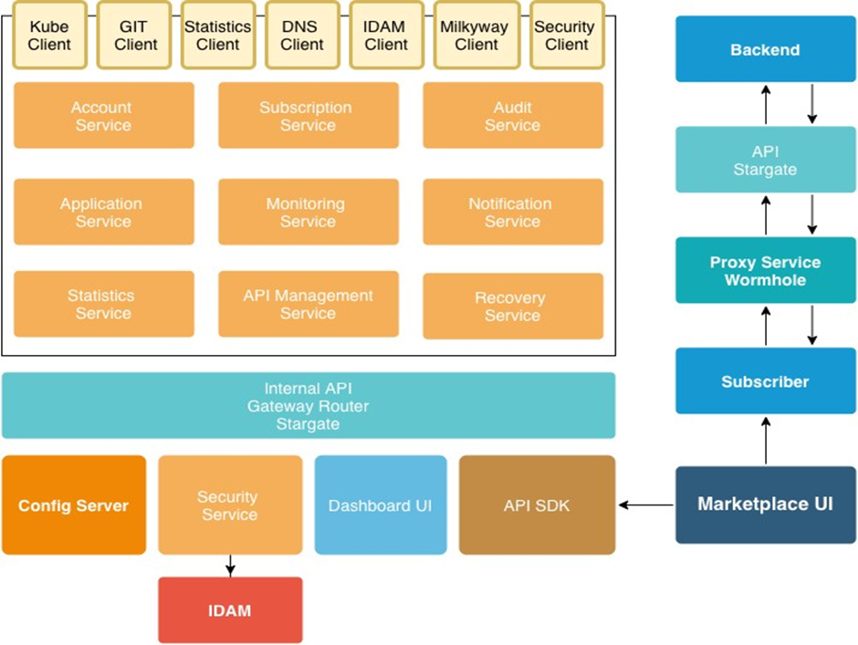

And is deployed in Google cloud with at least 2 different data centre locations.
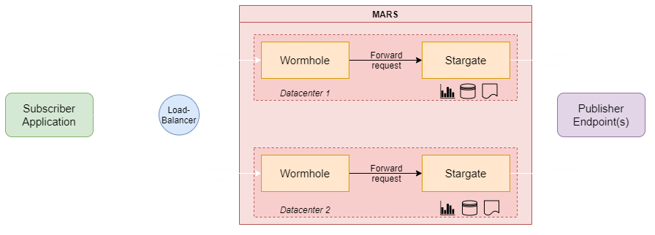
Two authentication modes are supported:

Decoupled
- Different types of authentications used by client and backend (mix of OAuth2, Basic, IDAM Oauth2, etc.)
- MARS acts as a consumer for the backend API, the API backend sees MARS as caller
- Especially useful for legacy backends and/or apps
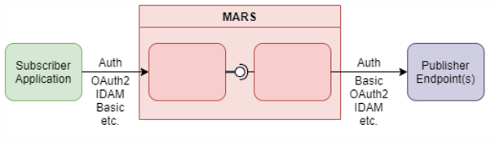

Single-Token IDAM Auth
- Both consumer and provider must use IDAM OAuth2
- Backend API sees subscriber itself as caller
- Two working modes: MARS IDAM client, alternative IDAM client
- Fins-grained control on API backend
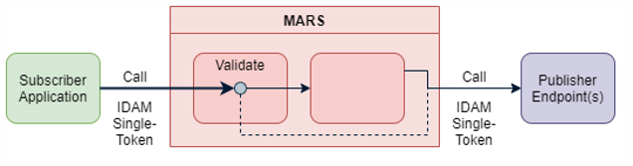

MFT Platform (METRO File Transfer by JScape)
MFT is a highly available, scalable and self-service platform offered to internal and external users for secure file transfer supporting SFTP. Currently used in 18 countries and more than 50 products.
Please note that MFT connections and flows are not in scope of this SoW, so this chapter is for information purpose only.
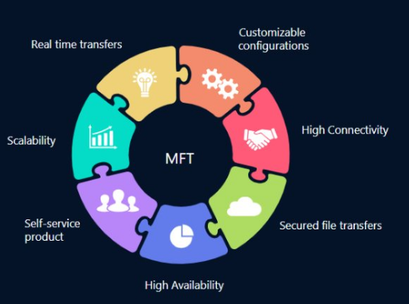
MFT nodes run on two data centres and is served using HA F5 load-balancers.
Each MFT domain runs separated from others, having their own port, users, folders and administrative settings.

Architecture
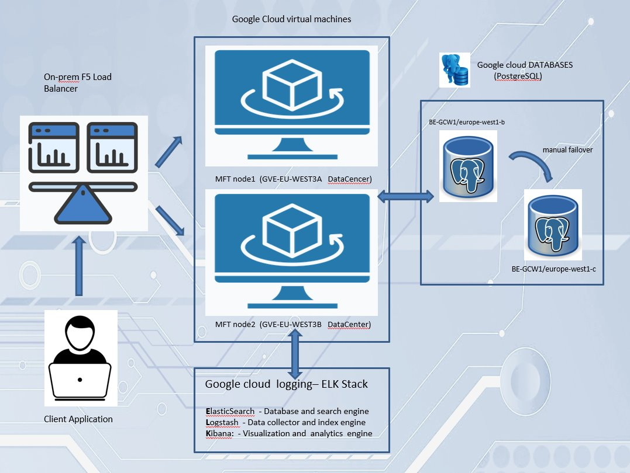
Load Balancer – OnPrem – represented by the DNS address clients use to access MFT – the IP behind it changes when the data centre is switched (failure, load, etc).
MFT nodes – 2 different servers where the JScape application is configured – on separate data centres in GCP
Database. PostgreSQL with manual failover also configured in GCP
Logging – ELK Stack. GCP configured.

MIP (METRO Integration Platform)
The MIP contains of three major parts:
- MCC Middleware
- CTA Middleware
- M Adapter

Provided capabilities
- High performance data transfer
- Dynamic scalability
- High availability
- High connectivity
- Security
- Full transparency
- Routing / multicast
- Single point of transformation
- Automation

Technologies currently used
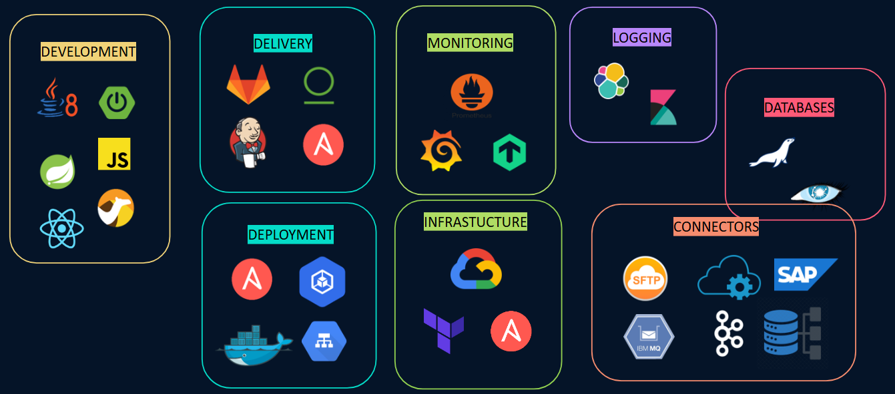

MIP team activities
- End-to-end development process of the platform including analyses, design, implementation, testing and configuration​
- Consultancy on software implementation and optimization of the platform​
- Responsible for the deployment, operation and maintenance of the integration components together with the whole GCP cloud infrastructure stack on which the platform is running.​
- Operational services include installation, configuration, administration, logging and monitoring, incident management, reports creations and second level support.

Middleware workflow
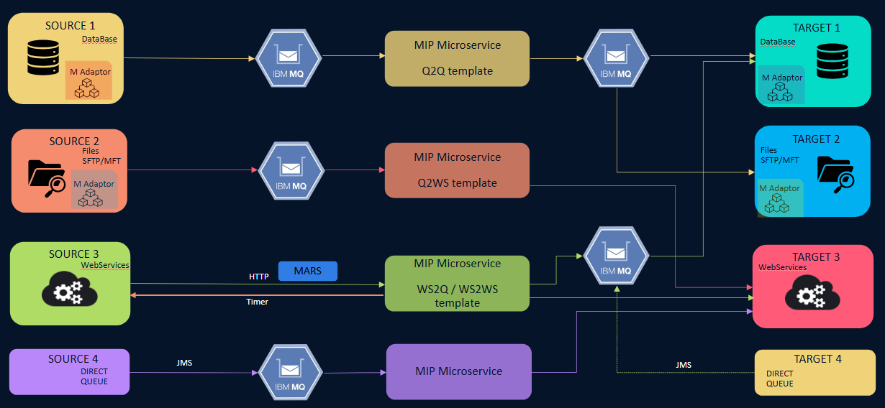
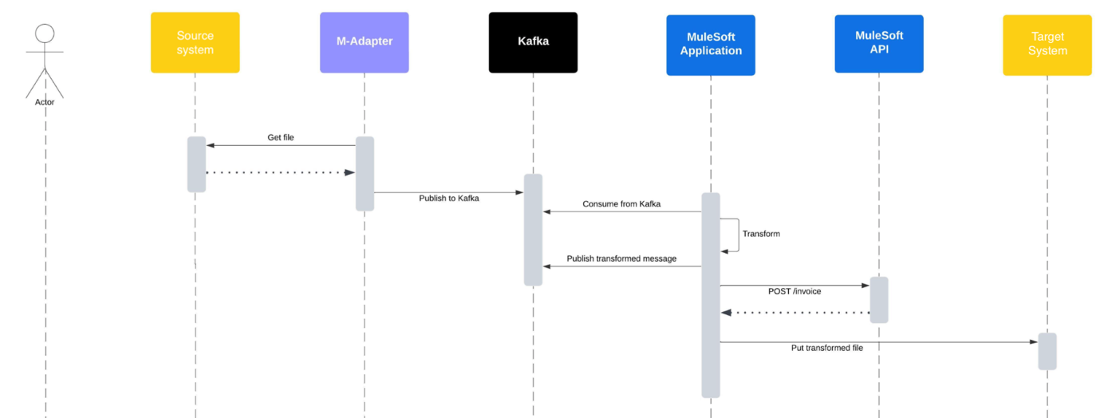

MIP architecture
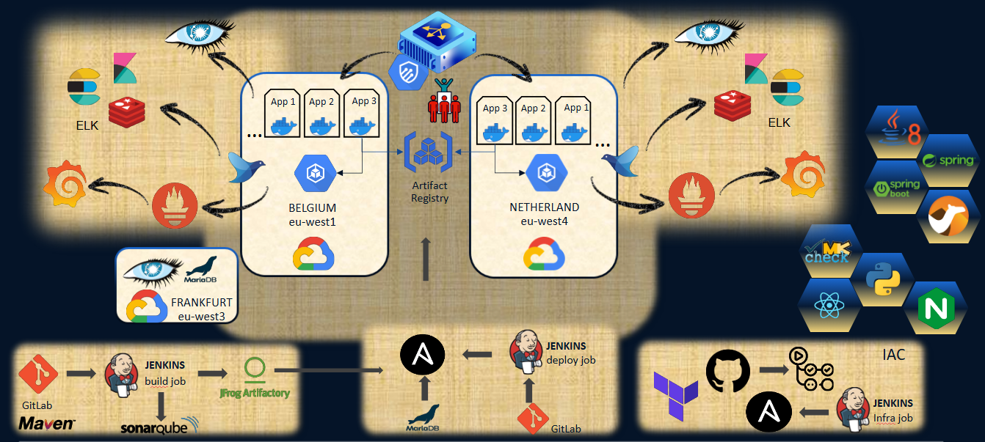

MIP Dashboard
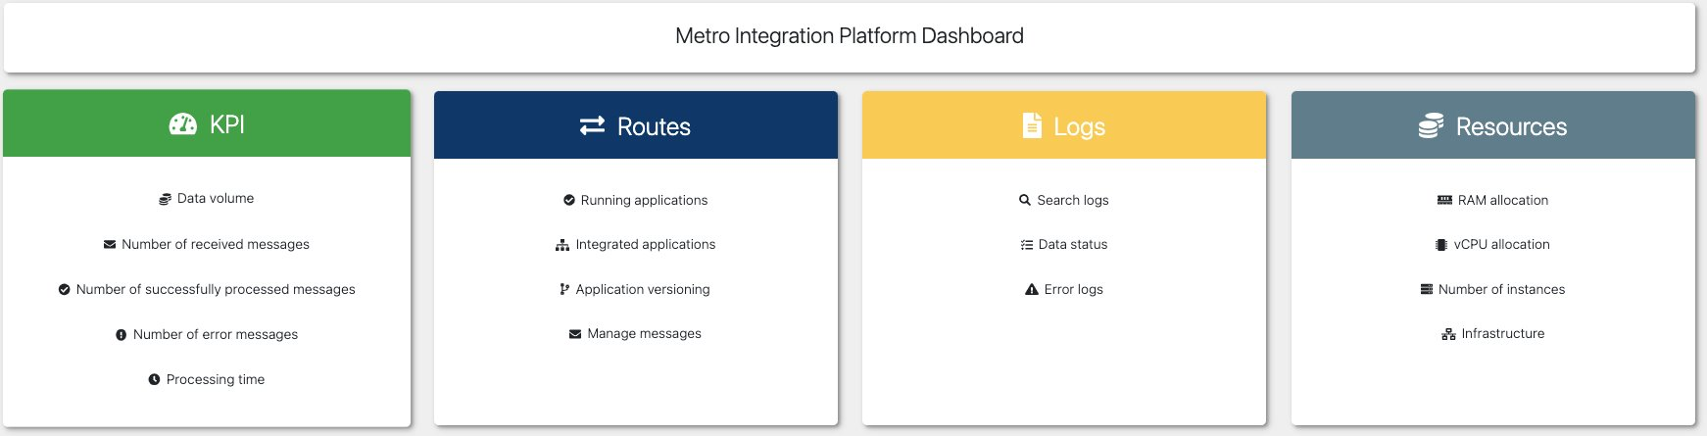

MCC Middleware
- Implements Enterprise Integration Patterns (EIP)
- Template integration flows (queue2queue, queue2ws, ws2queue, ws2ws, …)
- Integration flows as microservices: routing, transformation (XML, CSV, JSON, Custom), normalization, logging
- Deployment per country
- Point-to-point or Multicast supported
- Transferred data includes Master Data (e.g., articles, discounts, promotions, labelling, taxes, fees), Order shipments, advice notes and traceability data, reports, customer data & credit checks, stock checks & reservations, loyalty data, debts, charges and refunds, order transfers and feedback, invoices, etc.
Please find a list of current MCC middleware interfaces / flows in Annex 5

CTA Middleware (Common Template Accounting)
- Build on top of MIP
- Offered services are analysis, design, development, automated testing, operational services including installation, configuration, administration, logging and monitoring, incident management, second level support, maintenance
- 19 source systems are connected using CTA/X with 37 flows and 138 instances in 15 countri
- 14 source systems are connected using LUCA with 42 productive interfaces and 89 instances
- Check Mk and ELK used for monitoring infrastructure
- CTA is used to connect to the older SAP system using mainly flat files as source and as a target
- LUCA is used to connect to the new SAP system, using mainly flat files as source and iDocs as target
- During processing some of the routes may connect to three webservices, but not necessarily to all three of them. These are:
  - temporary status webservice - persistence layer which "held" data needed from one block to another.
  - enrichment webservice - retrieves business values (maintained by business guys); this is more like a VLOOK UP table, but which can have multiple columns as "value ins" and/or combinations
  - RFC - calls to SAP system functions for retrieving data during processing
- The CtaCore library extends MIP Common lib and all of CTA flows/routes are using it.
  - Apache camel custom processors used by CTA flows – e.g.: for setting external properties to exchange object header
  - Methods to connect and use CTA "external" web services (those three from above) – e.g.: how enrichment webservice is called
  - Clear cache mechanism for enrichment webservice values
- The production environment manages per month about
  - 4.2m messages with 92ms average processing time
  - 35GB total size of messages
  - 9kb average size of a message
Please find a list of current CTA and LUCA flows in Annex 6

Architecture
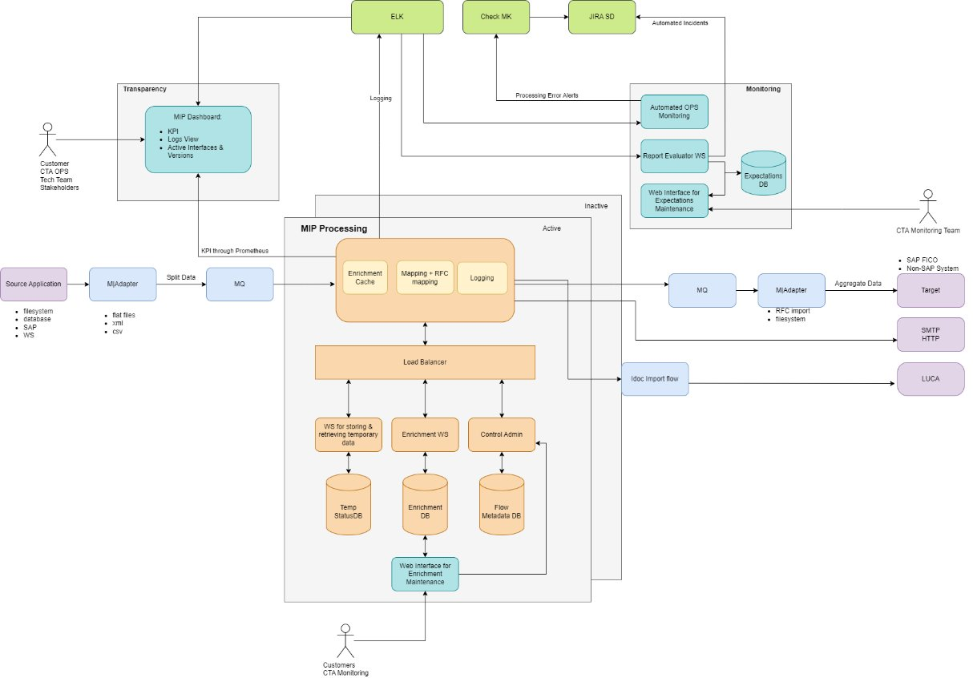
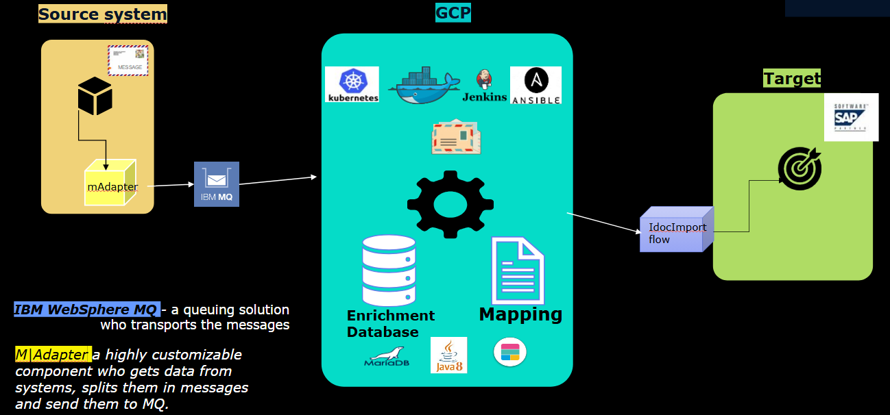

M.Adapter (METRO Adapter)
- Technical product used in partnership with MIP to provide connectivity for any type of system, regardless of platform, protocol or data format
- Facilitates the integration of different services
- MIP relaying on its Technical and business functionalities
- Build in-house on Java
- Provides connectivity for databases (Oracle, Teradata, SQL Server), files systems, SAP Java Connector, JMS (e.g., WebSphere MQ), Apache Kafka, HTTP, FTP WebServices
- Supports local and ELK logging
- Fully remote control in MIP Dashboard (auto discovering instances, centralized instance status, remote configuration orchestration, version control, remote control commands)
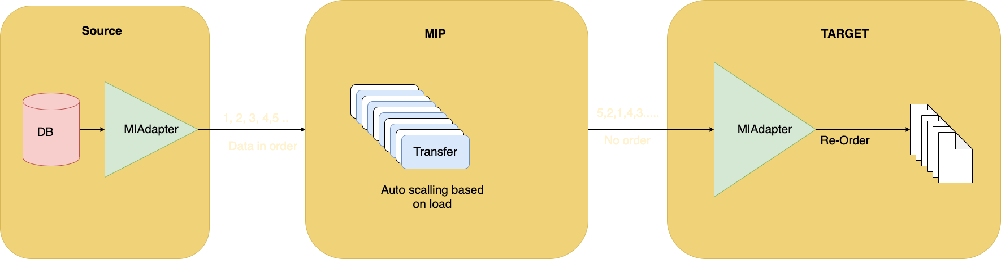
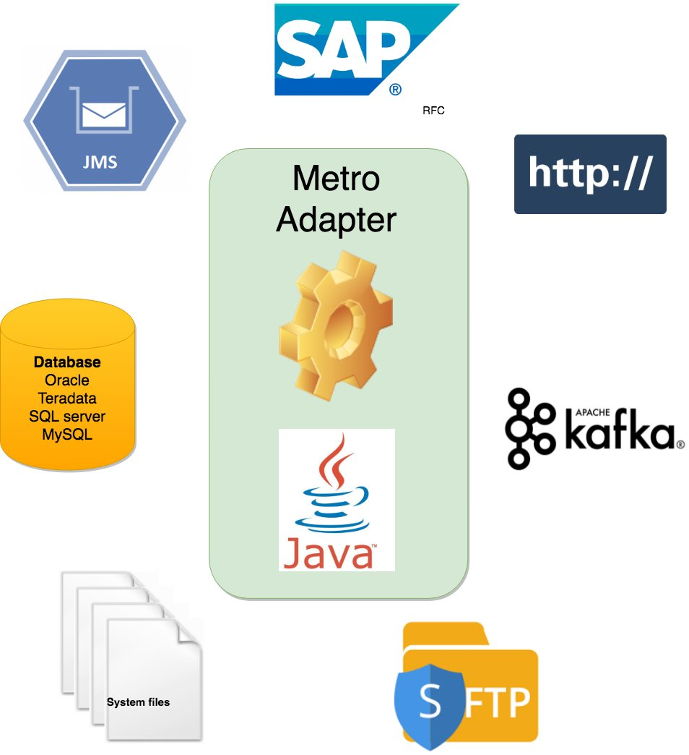
For more detailed information, please refer to Annex 3 – M.Adapter operating handbook.

Example screenshots MIP Dashboard
Auto discovering instances and centralized instance status:
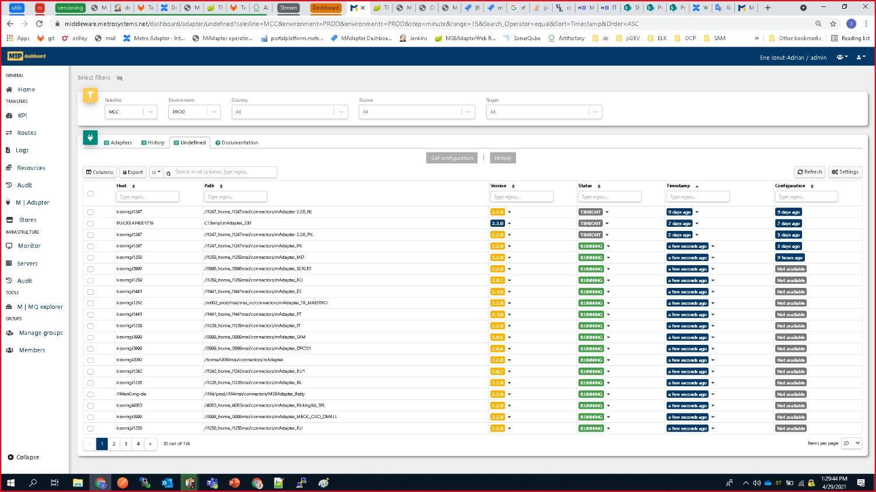
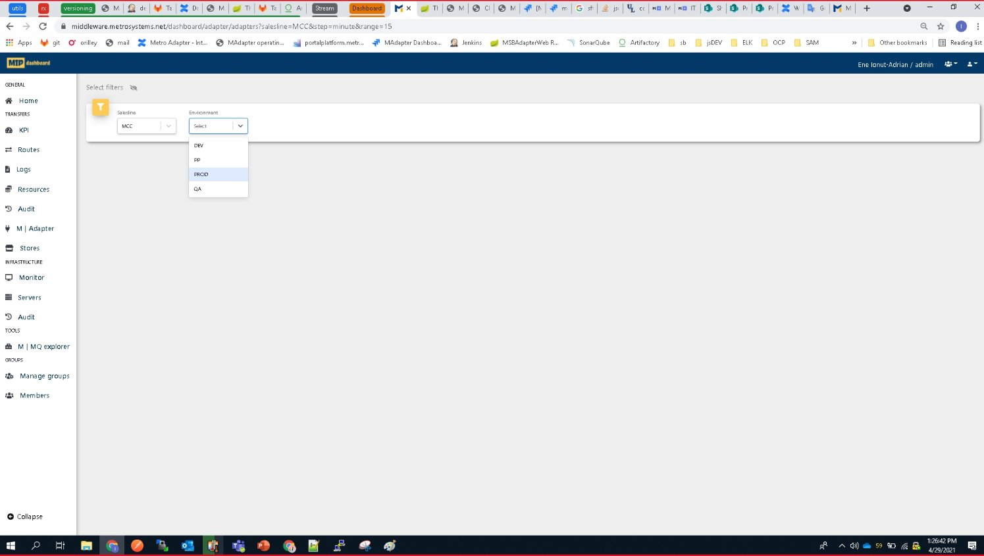
Remote configuration:
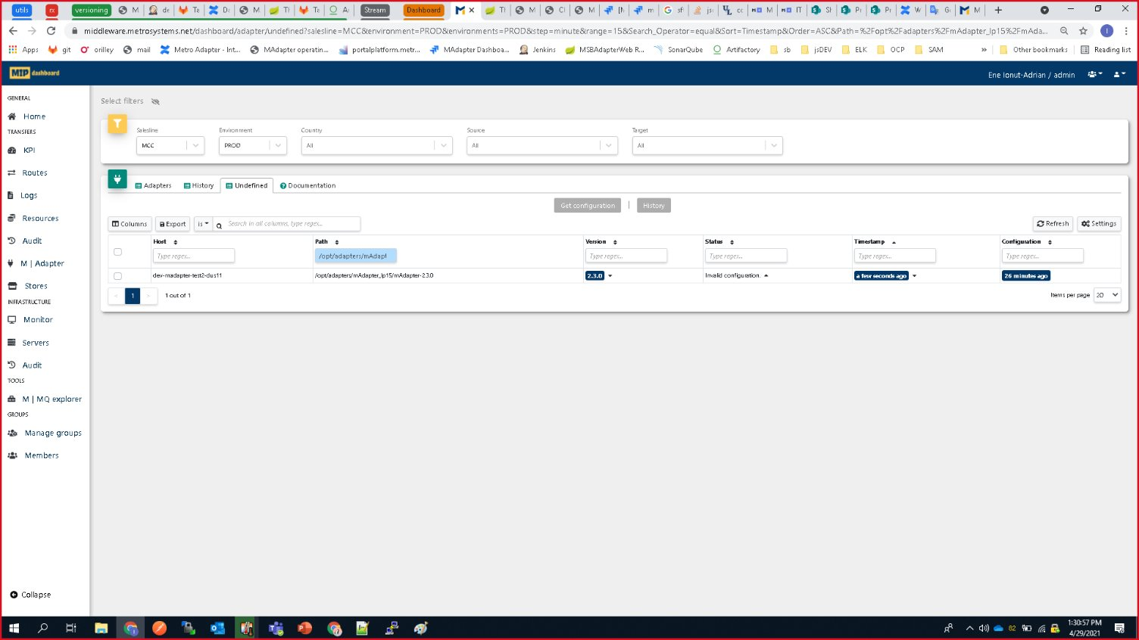
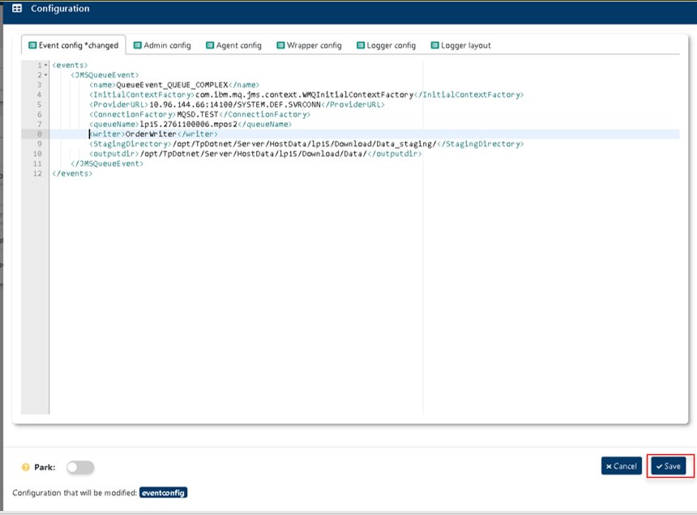
Remote control commands:
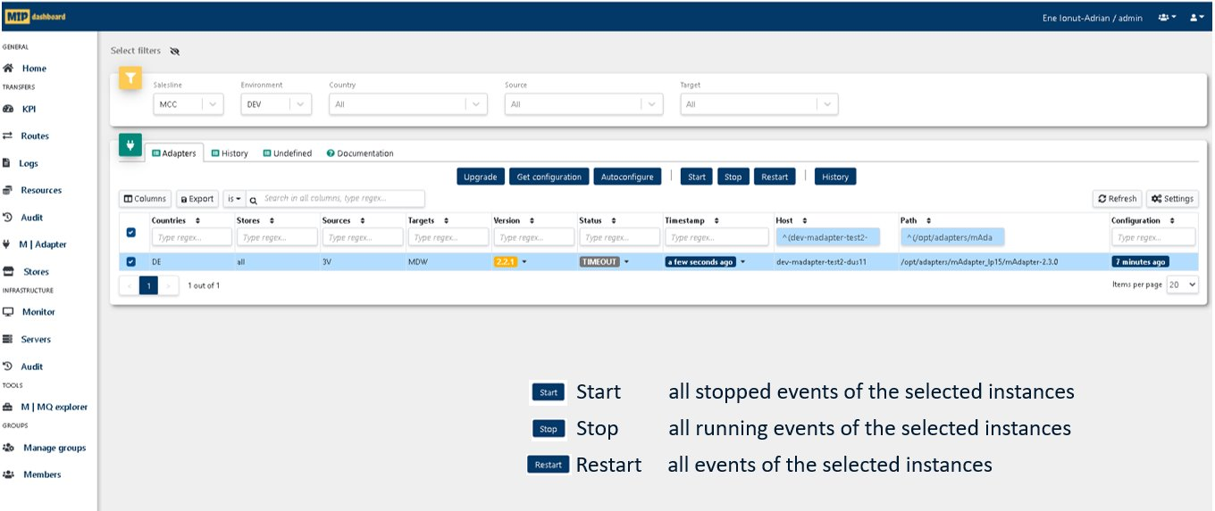

Developer Portal (M.API)
The developer portal (M.API) provides design and runtime information about API based interfaces.
Please find a detailed description of the Developer Portal in Annex 2.

Technical solution PoC messaging
During a previous PoC, this target architecture guideline was prepared:
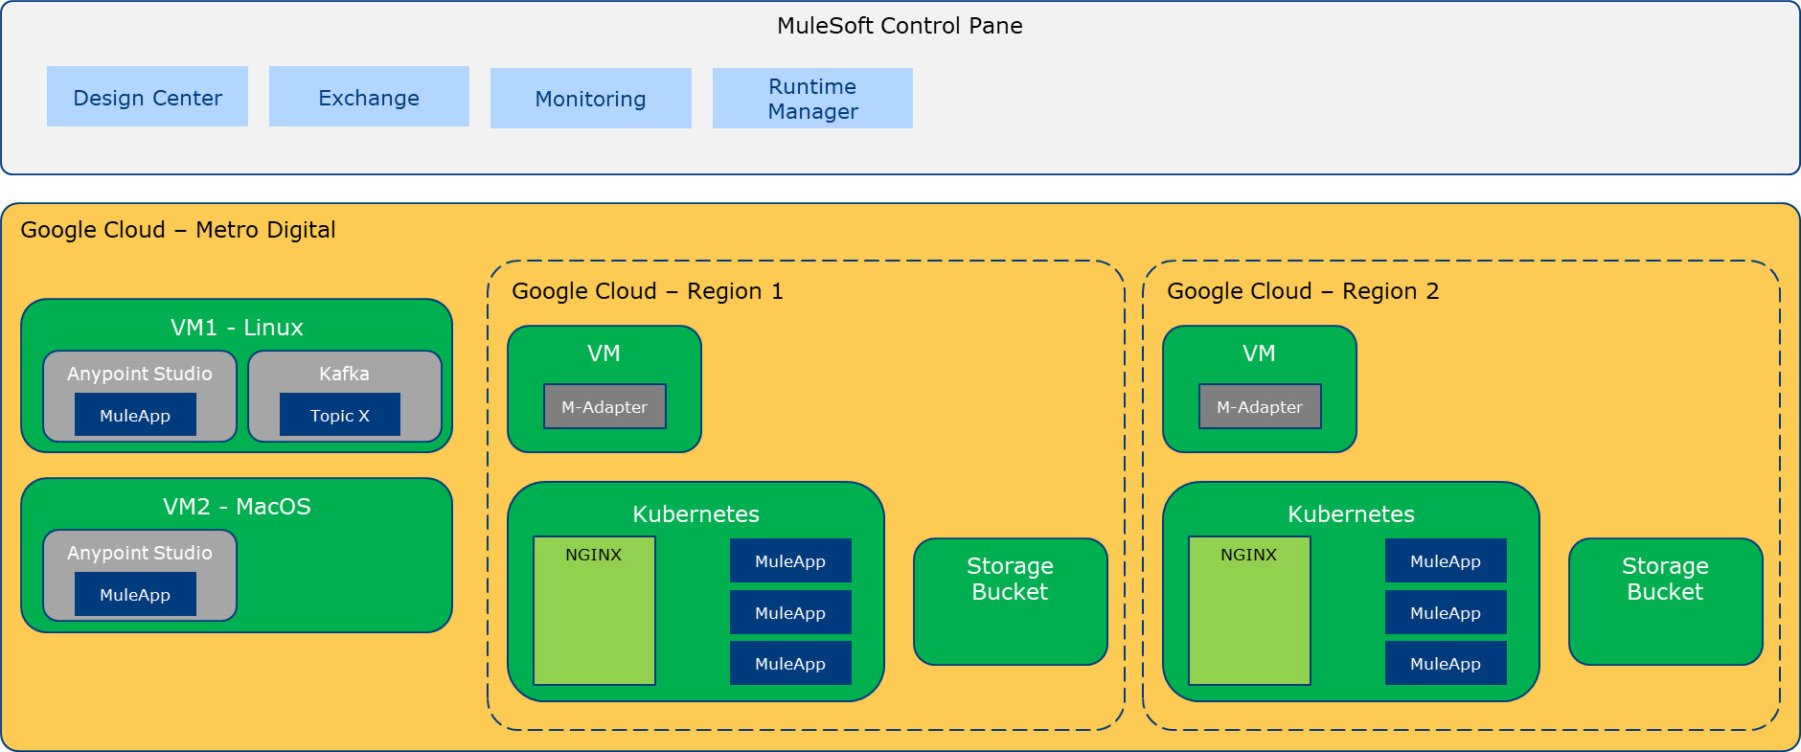

Technical solution PoC API gateway
During a previous PoC, these target architecture guidelines were prepared:
- Apigee consolidates and centralises API management in one place, streamlining administrative overhead, as demonstrated in the fanout and multi-step functionality proven during this PoC.
- The customisable developer portal provides an interactive and branded portal to onboard and engage third-party developers. This was proven during a previous PoC.
- Advanced security protects APIs from threats using encryption, authentication, and policy enforcement. As proven during this PoC, it can be coupled with Cloud Armor to further enhance the security at network level.
- Comprehensive monitoring providing real-time dashboards for monitoring API traffic, performance, and overall health. And its integration with the familiar Cloud Operations suite provides a unified experience for observability and will interface with DataDog (METRO internal observability platform).

Current state and challenges

General
- METRO currently ingests data from two primary sources - Kafka and HANA DB. However, the company anticipates onboarding additional data sources in the future, highlighting the need for a solution that can seamlessly accommodate new data streams without significant disruptions.
- The existing system utilizes separate schema definitions for each data source. This approach can lead to complexities in data harmonization and transformation processes, particularly as the number of sources increases.
- The current transformation logic employs a mix of programmatic and manual approaches. While this flexibility might address immediate needs, it can introduce inconsistencies and increase the risk of errors in the long run.
- METRO's development teams favour lightweight programming languages like JavaScript , along with configuration languages. This preference underscores the need for a solution that supports these languages to facilitate efficient development and maintenance.
- The system must be capable of handling substantial data volumes. Input files from M-Adapter can reach sizes up to 400MB, necessitating robust data processing capabilities to avoid performance bottlenecks.
- METRO has implemented a CICD pipeline for deploying changes to its production environment. This existing infrastructure can be leveraged for streamlining the deployment of new data integration solutions.
- METRO's current infrastructure, which includes Ansible and Jenkins, presents challenges in terms of maintainability and user-friendliness. These pain points emphasize the need for a modernized solution that reduces the operational overhead associated with infrastructure management.

CTA specific
- The current system relies on IDocs for transmitting data to SAP. While SAP's capacity to receive a high volume of IDocs per hour is beneficial, the requirement to send individual IDocs for each invoice can introduce complexities in the integration process.
- METRO maintains a private connection to SAP using a private IP address. While this ensures secure data transfer, it also necessitates careful consideration of network infrastructure and security protocols within the solution design.

In summary, METRO's current data integration environment is characterized by a complex interplay of data sources, transformation requirements, and legacy infrastructure challenges. The company's preference for lightweight programming languages, the need for high-volume data processing, and the existing SAP integration through IDocs are key considerations for designing a future-proof data integration solution. Addressing the pain points associated with the current infrastructure will be crucial for improving operational efficiency and enabling METRO to scale its data integration capabilities effectively.

Project description

Project objective
The goals of the project ‘Integration Factory’ are to drive standardized, streamlined, and modern integration for speed and flexibility.
- Enhance and adopt (if necessary) the concept of the Integration Reference Architectureand implement integration factory to unify the heterogeneous solution landscape at scale.
- Standardize integration patterns / technologies and governance / guidelines across entire METRO organization.
- Replace MIP and MARS with a modern highly adaptable integration platform as the enabler for large initiatives and other architecture changes.
- Optimized development of APIs & integrations to speed up deployment times and improve pain points like technology related data quality issues.
- Enhance M-Adapter use of Kafka
- Adopt and introduce a new CI/CD pipeline
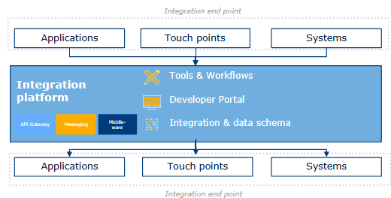

Project scope
The Integration Factory will deliver a centrally developed, standardized integration platform designed to streamline, accelerate, and govern the development and management of integration solutions across the organization. This initiative will enable seamless connectivity between internal systems, applications, and external counterparties through standardized APIs, middleware, messaging services, and data integration capabilities.

The following chapters describe the scope of the project:
- Update the Developer Portal (M.API)
- Replace MARS (METRO API Repository & Security) with Google Apigee
- Replace METRO Integration Platform (MIP)
Out of scope are:
- Update / integrate MFT (METRO File Transfer by JScape)
- Management of master data quality and governance​
- New integrations to be built directly on the new Integration platform​
- Migration of known unknowns (e.g. all integration transfers in MMS not usingMIP; integrations specific per country or solutions)​
- Capturing of Country Integrations

Update Developer Portal (M.API)
The Developer Portal (M.API) needs to be adopted to connect to Google Apigee to provide current functionalities. During the roll-out phase, M.API must support the current and new API GWs.

Replace MARS (METRO API Repository & Security) with Google Apigee
Replacing the MARS platform with Google ApiGee platform for the current 344 APIs manage by the platform. This contains tasks like
- Analyse the existing API (including discovery)
- Creation of a target API specification and footprint
- Update the documentation
- Align API changes with the users (if applicable)
- Setup the API in Google ApiGee
- Define and request applicable infrastructure changes
- Testing
- Roll-out
A list of current APIs and instances could be found in the Annex 4 - APIs

Integrate with MFT (METRO File Transfer by JScape)
Currently, it is not planned to upgrade or replace MFT. The new messaging platform must interface with MFT.

Replace METRO Integration Platform (MIP)
Replacing the MIP platform with the Mulesoft platform for the current 346 instances and 1830 flows manage by the platform. This contains tasks like
- Analyse the existing instance and country/platform specific flows
- Creation and implementation of a target instance specification and footprint and interaction with M.Adapter
- Update the documentation
- Align interface changes with the users (if applicable)
- Define and request applicable infrastructure changes
- Testing
- Roll-out

Project milestones

Foundation phase
During the foundation phase until October 2025) the concepts and guidelines will be refined, the team setup finalized, and trainings performed.
The definition of templates and guidelines to use the new Integration Factory will be created and published.
Please note that this phase will be performed by METRO internal resources and prepares for the upcoming roll-out and decommissioning phase, where the SI is mainly involved.

Roll-out and decommissioning phase
The roll-out and decommissioning of the messaging (MIP) and API Gateway (MARS) related interfaces will be performed in parallel.
The definition of the interfaces to be rolled-out per week will be done dynamically to optimize and align with other projects (e.g., LUCA – SAP project).

Messaging (MIP)
The current project plan is based on
- MIP instances (in production and test environments)
  - Baseline scenario:
    - 154 MIP instances (17 MCC, 60 CTA)
    - ~900 country/platform specific instances (flows)
  - Extended scenario (total):
    - 346 MIP instances (98 MCC, 75 CTA)
    - 1830 country/platform specific instances (flows)
- One roll-out windows per week
- Roll-out of 1 instance each (MCC production, CTA production, MCC test, CTA test) per roll-out windows
- Start of the roll-out phase in November 2025
- Decommissioning of legacy instances/flows is performed 4 weeks after the roll-out of new the instances/flows
- Completion of roll-out is planned for
  - Basline scenario: February/March 2027
  - Extended scenario: August 2027
- The sequence of the roll-out should be in order of complexity. Strating with group 1 (lowest complexity) to 7 (highest complexity – non-standard as-is solutions):
  - Group 1: Standardized solution, no mapping, only one country, no MPOS instances
  - Group 2: Standardized solution, no mapping, multiple countries, no MPOS instances
  - Group 3: Standardized solution, low-medium mapping complexity, no MPOS instances
  - Group 4: Standardized solution, high mapping complexity, no MPOS instances
  - Group 5: Standardized solution, source system MPOS
  - Group 6: Standardized solution, target system MPOS
  - Group 7: Non-standardized solutions

API (MARS)
The current project plan is based on
- 344 APIs to be migrated
- Two roll-out windows per week
- Roll-out of 3 APIs per roll-out windows
- Start of the roll-out phase in November 2025
- Decommissioning of legacy APIs is performed 4 weeks after the roll-out of new the API
- Completion of roll-out is planned for February 2027
- The sequence of the roll-out should be in order of number of instances of the API.
  - Group 1: 0 (to be validated if still needed) or 1 instance: 143 APIs
  - Group 2: 2 instances: 80 APIs
  - Group 3: 3 instances: 49 APIs
  - Group 4: 4-6 instances: 45 APIs
  - Group 5: 7-19 instances: 31 APIs
  - Group 6: >19 instances: 10 APIs

Project approach

The roll-out of the new messaging and API platform should happen in parallel, as there are only a few dependencies between these two platforms.
The grouping of the as-is instances could be found in Annex 4 and Annex 5.
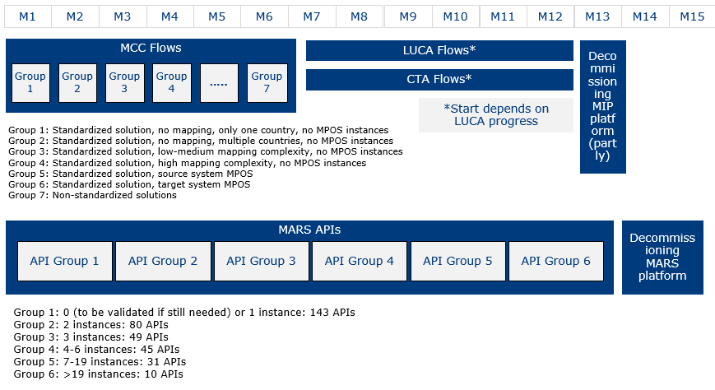

Project Timeline
The roll-out and migration of MIP flows and MARS APIs should be done in parallel and according to theis high-level roadmap and timeline.

Baseline scenario:


Extended scenario:
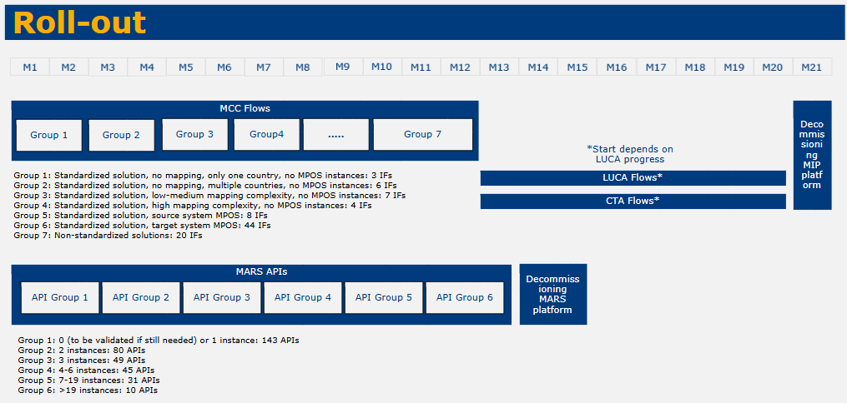

Deliverables
List and describe ALL deliverables that SP* needs to provide/hand-over as a result of the services
Deliverable Name | Description of Deliverable | Acceptance Criteria
Flow Inventory | An inventory of all flows managed by the Mulesoft platform, containing all technical details (e.g., mapping, implementation and configuration, operational parameters and guidelines) | Completeness  Part of the METRO Digital confluence platform
API Repository | A repository of all APIs, managed the Google Apigee, connect and integrated with the Developer Portal, containing technical details (e.g., URL, Swagger / JSON API footprint, implementation and configuration, operational parameters) | Completeness  Integrated into Developer Portal
Test reports | Detailed reports what and how each migrated flow or API was tested and what results have been achieved | Completeness
Architecture documentation | Detailed system diagrams documented and explained for both products (api and messaging) | Completeness  Part of the METRO Digital confluence platform
Mulesoft flow integration cookbook | As part of phase 1 we develop the “factory” that contains reusable patterns for integration in the mulesoft platform. The reusable patterns must be documented, explained, with associated system diagrams. As a technical and business representative of any solution in the metro digital landscape I need to understand how to create new integrations in my system’s landscape reusing patterns inside the “integration factory” | Completeness  Part of the METRO Digital confluence platform
API gateway and developer portal product documentation | Must have a clear vision and product description documented as part of the integration factory “cookbook”. As a technical or business representative of any solution in the metro digital landscape I need to understand how to use and what are the responsibilities and features of the new gateway and developer portal | Completeness  Part of the METRO Digital confluence platform

All deliverables are subject to an overall acceptance test by METRO

SLAs, KPIs and NFRs
In case of the agreed service level falls below the KPI, SP* must submit improvements plans for the relevant service levels.
SP* is also required to propose suitable Service Credits in case of failures, for reasons which lays under SP*s responsibility

Service Level Agreements (SLA)
Please refer to Annex 7 – NFR_SLA.xlsx

KPIs for soft benefits

Improved observability​
Improved toolset for monitoring traffic and business processes globally and doing ad-hoc issue analysis and resolution. Dependencies management improves and supports large architectural transformations​

How to measure and KPI threshold?
- Number of monitored flows and processes
Threshold: >90% of flows managed by Integration Factory are integrated with the monitoring
- Reduction of time to analyze as-doc issues
Threshold: Avg. resolution time <30% (today 318min)

Effective cost control​
Close monitoring of API client’s usage and traffic volume measurements allows optimization of the setting​

How to measure and KPI threshold?
- Number of monitored productive APIs
Threshold: >95% of productive (active) APIs managed by Integration Factory are monitored

- Usage values available and historical data available
Threshold: Hourly traffic data is available for >95% of manages APIs
Threshold: Min. 3 months of historical data available

Reduced skill risks​
Expertise in fewer technologies to maintain, thus, reducing risk from personnel turnover or absences​
How to measure and KPI threshold?
Not applicable to be used in a KPI

Higher data quality ​
Central consistency checks and smart error handling can solve specific data transmission problems.
Integration Factory is a major enabler for other programs like Master Data Management.​

How to measure and KPI threshold?
- Number of data transfer related incidents
Threshold: 90% reduction of incidents caused by missing or incomplete data transfers of flows managed by Integration Factory (reference Jira Feb 2024 – Feb 2025: 989 incidents)

Reduction of error rate and improved success rate
Reduce the number of failed jobs due to transformation, schema mismatches of connectivity issues.
Increase the success rate for all data integration jobs (e.g., ETL/ELT processes, API calls, data syncs).

How to measure and KPI threshold?
- Gather data from monitoring logs about failed job with reason transformation, schema mismatch or connectivity.
Threshold: 80% reduction of failed jobs managed by Integration Factory
- Gather data from monitoring logs about ETL/ELT processes, API calls and data syncs
Threshold: >90% success rate of jobs managed by Integration Factory

Non-Functional Requirements (NFRs)
Please refer to Annex 7 – NFR_SLA.xlsx

Roles and Responsibilities

Project Manager
- Coordinate functional and technical analysis and realization in close collaboration with the project team and the specialist units.
- This is a METRO internal role

Squad Lead
- Prioritize the backlog items defined by the team to maximize the value of the product and refine the ideas together with the team.
- This is a METRO internal role

Platform Lead
- Drives platform mission and success, by taking full accountability for delivering outcomes, re-evaluate the platform purpose, define and track KPIs, own the P&L, create and maintain the platform roadmap
- Creates alignment within and across platforms
- This is a METRO internal role

Technical Architect
- Organize the structure of the system and design how its components interact with each other.
- This is a METRO internal role

Full Stack Engineer (Development)
- Involved in all phases of software engineering, from inception to coding, testing, delivery and operation.
- Develop high quality code that follows best practices and clean code principles.
- Advocate for improvements to product quality, security and performance.
- Collaborate with other engineers or team members on various layers of the infrastructure, to design and launch new features.
- Testing Process: Applies test estimation, metrics, business value of testing, test prioritisation, defect reporting and lifecycle.
- Analytical Thinking: Aligns appropriate solutions to issues by evaluating information they gathered and by considering their urgency and importance.
- This is a shared role

Full Stack Engineer (Test)
- Involved in all phases of software engineering, from inception to coding, testing, delivery and operation.
- Develop high quality code that follows best practices and clean code principles.
- Advocate for improvements to product quality, security and performance.
- Collaborate with other engineers or team members on various layers of the infrastructure, to design and launch new features.
- Analytical Thinking: Aligns appropriate solutions to issues by evaluating information they gathered and by considering their urgency and importance.
- Coding: Understands, writes and reads codes and applies coding and security best practices.
- This is an external role

Pricing and Payment Terms
This project will be executed by SP* based on a Fixed Price model, for a total amount of ……. EUR.

Fixed Price Payment will be due according to the following payment schedule:
Milestone completed | Payment amount (EUR)

SP* is requested to provide 2 separate offers, one for each scenario (Baseline and Extended scenarios), taking into account the requirements described in Chapter 4.3.2 (Roll-out and decommissioning phase/Messaging (MIP)) and Chapter 5 (Project Timeline).

SP* will provide an overview with estimated efforts needed to realize the project goals, by roles/skills, for illustration purposes.

Assumptions
The audience has a basic understanding of cloud architecture and the relevant components like storage, networking, and security. A high-level understanding of big data processing (for example, batch processing) and streaming is also necessary.

Glossary
Term | Description
Integration Platform | A group of solutions and technologies providing the integration as technical capability between counterparties.
Counterparty | METRO Solutions and IT Components taking part in one or many integrations.
Interface | Realization of an integration contract between two or many counterparties
Provider | A Counterparty that provides data and/or messages
Consumer | A Counterparty that consumes data and/or messages
Message | A structured data item transmitted from Provider to Consumer. It generally has two parts, a header describing data being transmitted, and a payload as data being transmitted. Messages can be of various types: commands, queries, events or responses.
Integration type | A method used to combine certain software components to enable integration for specific requirements and messages.
API-based integration | An integration type where APIs serve as the interface through which systems interact, allowing them to access data and functionalities based on a predefined contract between API Provider and API Consumer.
Point-to-Point based integration | An integration type where there is only one Provider and one Consumer, while the communication can be direct or through an intermediary component (ex. queue).
Publish/Subscribe based integration | An integration type where Providers generate messages and publish them to one or more channels, and Consumers express interest in specific topics and receive messages that are published to those channels.
Middleware based integration | An integration type where middleware serves as an intermediary layer between Provider s and Consumers, providing a set of services for integrating and coordinating interactions between them. One example is Extract Transform Load (ETL) tools.
Change Data Capture based integration | An integration type used to capture and propagate changes made to data in a database or data source in real-time or near-real-time.
EDI based integration | An integration type based on Electronic Data Interchange standard to facilitate the exchange of business documents and transactions between different organizations or trading partners.
API Leveling | Classification of APIs by levels of access for different consumers.
External entity | Non-METRO legal entities interested in integrating and exchanging data with METRO: Customers, Suppliers, Partners, Logistic Service Providers, Government.
RPA | Robotic Process Automation (RPA) is a technology that uses software robots or 'bots' to automate highly repetitive, routine tasks that were previously performed by human workers. These tasks typically involve interacting with digital systems and software, such as data entry, transaction processing, or responding to simple customer service queries.
TLS | Transport Layer Security (TLS) is a cryptographic protocol designed to provide secure communication over a computer network. It is widely used to secure data transmitted over the internet, ensuring privacy and data integrity between communicating applications.
OAuth2 | OAuth 2 (Open Authorization) is an authorization framework that allows third-party applications to obtain limited access to a user's resources without exposing their credentials. It is widely used to grant websites or applications limited access to user information without compromising security.

References
Annex 1 – METRO Integration Reference Architecture
(Annex 1 - Integration Reference Architecture.pdf)
Annex 2 – Developer portal reference
(Annex 2 - DEP-Developer Portal Overview-070524-103142.pdf)

Annex 3 – M.Adapter operational handbook
(Annex 3 - MAdapter operating handbook 1.pdf)

Annex 4 – List of MARS APIs
(Annex 4 – APIs.xlsx)

Annex 5 – List of MIP interfaces
(Annex 5 – Middleware interfaces.xlsx)
Annex 6 – CTA and LUCA flows
(Annex 6 – CTA and LUCA flows.xlsx)

Annex 7 – NFR_SLA
(Annex 7 – NFR_SLA.xlsx)

